Name: _____________________________________________ Class: __________
2025 TERM ONE MZIMBA NORTH DISTRICT EXAMINATIONS

PHYSICS FORM 3
PAPER II
Date: 16th December, 2025

Time Allowed: 2 Hours
7:30am onwards
Practical
(40 marks)

INSTRUCTIONS
- This paper contains 6 printed pages. Please check.
- Fill in your name and class at the top of each page.
- Answer all 4 questions in the spaces provided.
- Use of electronic calculators is allowed.
- The maximum number of marks for each answer is indicated against each question.

©MZN-T1-2025
- a. With the help of a well labelled diagram explain how a thermocouple thermometer works.

___________________________________________________________________________________________________________________________________________________________________________________________________________________________________________________________________________________________________________________________________________________________________________________________________________________________________________________________________________________________________________________________________________________________________________________________________________________________________________________________________________________________________________________________________________________________________________________________________________________________________________________________________________________________________________________________ (6 marks)

b. Describe two advantages of the thermocouple thermometer ___________________________________________________________________________________________________________________________________________________________________________________________________________________________________________________________________________________________________ (4 marks)

- With the aid of a well labelled diagram, explain an experiment to show that shape of the container does not affect pressure of the liquid.

____________________________________________________________________________________________________________________________________________________________________________________________________________________________________________________________________________________________________________________________________________________________________________________________________________________________________________________________________________________________________________________________________________________________________________________________________________________________________________________________________________________________________________________________________________________________________________________________________________________________________________________________________________________________________________________________________________________________________________________________________________________________________________________________________________________________________________________________________________________________________________________________________________________________________________________________________________________________________________________________________________________________________________________________________________________________________________________________________________________________________________________________________________________________________(10 marks)

- You are provided with a rectangular wooden block, a beam balance and a 30 cm ruler.
- Measure the mass of the rectangular block on the beam balance
__________________________________________________________________
(1 mark)
- Place the rectangular block on the bench horizontally as shown in figure 2.
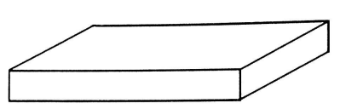
Figure 2
- Measure the length and width of the rectangular block at its base using the 30 cm ruler
_________________________________________________________(1 mark)
- Calculate the pressure exerted by wood block on the bench.

(2 marks)
- Place the same rectangular block vertically as shown in the figure 3.
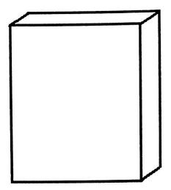

Figure 3
- Measure the length and width of the block of wood at its base
- Length _________________________________________ (1 mark)
- Width __________________________________________ (1 mark)
- Calculate the pressure exerted by the wood brock on the table

(2 marks)
- Compare the pressure exerted by the rectangular wood in a horizontal and vertical position.
_________________________________________________________________
(1 mark)
- Which factor of pressure is being investigated in the experiment?
_________________________________________________________________
(1 mark)

- You are provided with the following materials: 100cm³ beakers, spring balance, mass, water.
- Hang the mass on the spring balance. record the mass (m1) in the table of results.
- Pour water in the beaker up to the brim.
- Lower the mass on the spring balance so that it is half immersed in water. Record the new mass(m2) in the table of values
- Table of results.
Mass(g)
Mass in air(m1)
Mass on water(m2)
Difference (m2 - m1)
(3 marks)

- If the overflowing water was collected, what would be the mass of the overflowed water? ______________________________________________ (1 mark)
- What is the relationship between mass of water and volume of water at room temperature? _________________________________________ (1 mark)
- What is the volume of overflowed water? ____________________ (1 mark)
- Find the weight of water displaced using the formula: weight of displaced water = volume x density of water x acceleration due to gravity.

(3 marks)
- Determine the conclusion from the results of this experiment.
___________________________________________________________________________________________________________________________.(1 mark)

End of question paper

